Data Analysis Nanodegree Program

Project 1 – Explore Weather Data

# 1.0 Data Retrieval

The following queries are used to get the data from my workspace. My closest city is Seattle.

**Query #1: City Level Data Retrieval**

***Select * from city_data***

I could have used “**select * from city_data where city = ‘Seattle’**”, but I wanted to get the whole dump, so I can analysis different cities for learning purposes.

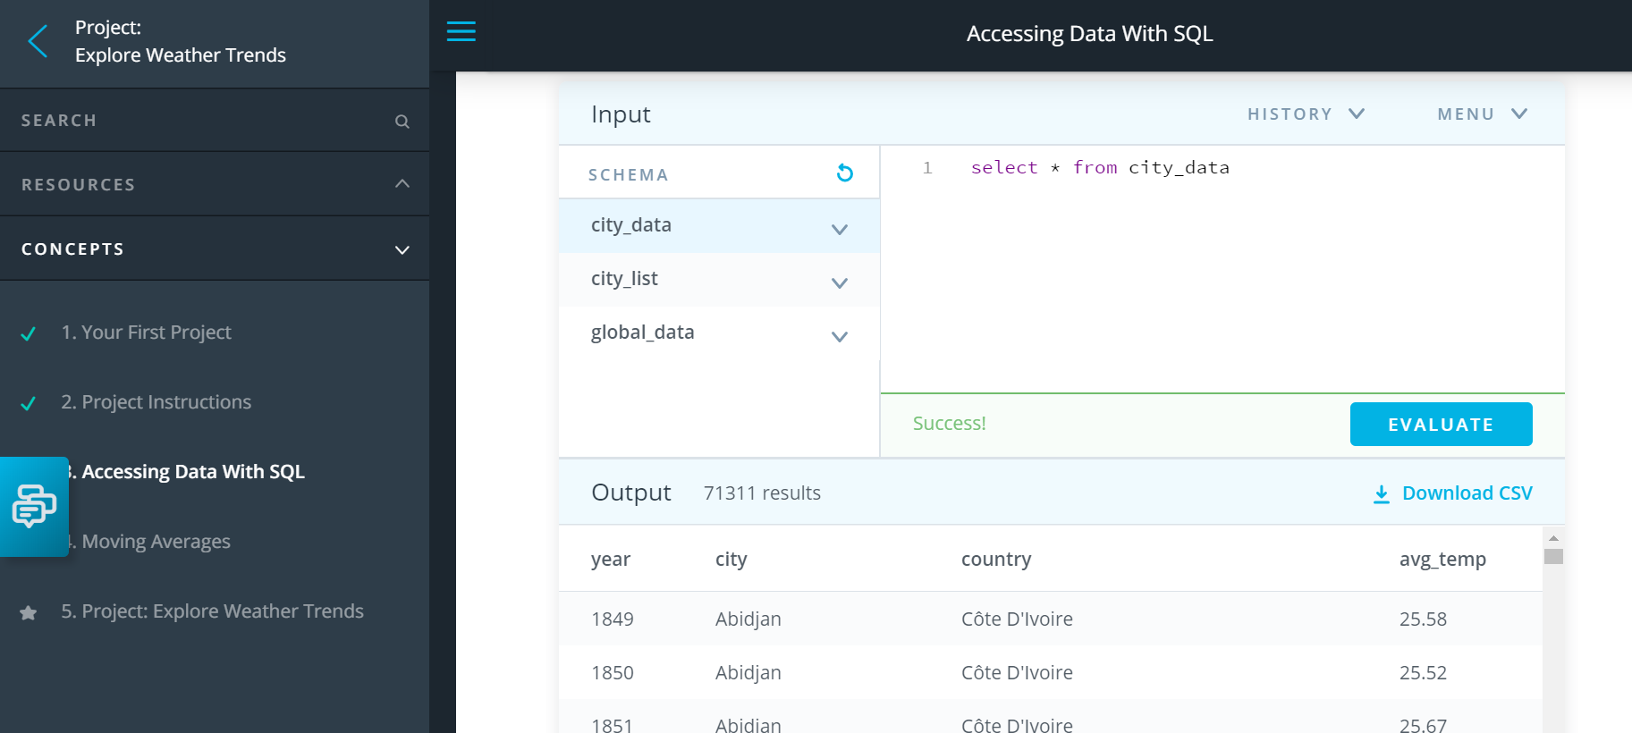

**Query #2: Global Data Retrieval**

***Select * from global_data***

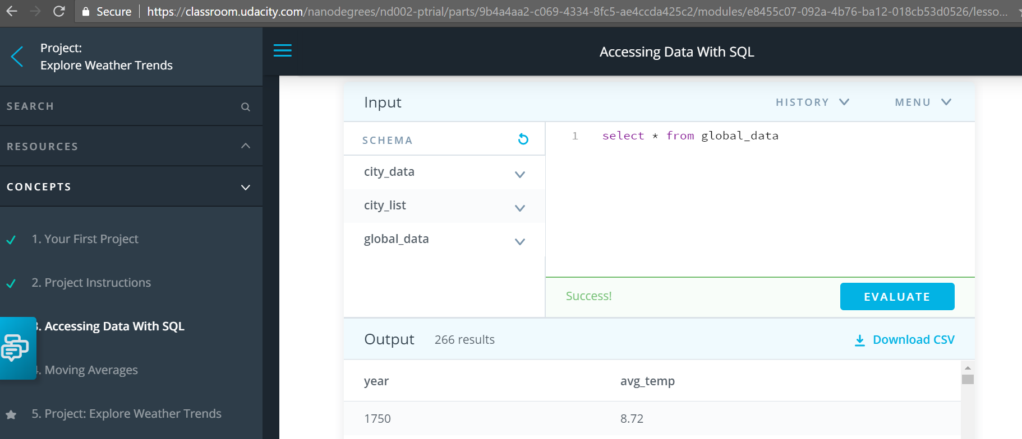

# 2.0 Calculate Moving Average

Moving Average is primarily used to smoothen the temperature results to make sure the data is not interpreted wrongly because of skews in temperature.

After storing all the data in one Excel file i.e. City temperature data in ‘city_data’ Work sheet, Global temperature data in ‘global_data’.

I did the following steps to calculate the moving average on city data.

**Steps**:

1. Format the data in table format in ‘city_data’ worksheet.
2. Added Slicers for ‘city’ and ‘country’ to filter only the city, we are interested. My closest city is Seattle. In the slicer, I chose ‘Seattle’ to get only Seattle City Data.
3. To calculate Moving Average for over 10 years, in the new column [CityData_10_Years], I included the below formula ‘=AVERAGE(D58799:D58808)’, and dragged the moving average formula for the rest of the year rows.
4. I also calculated Moving Average for over 25 years, in the new column [CityData_25_Years] to play with the data.

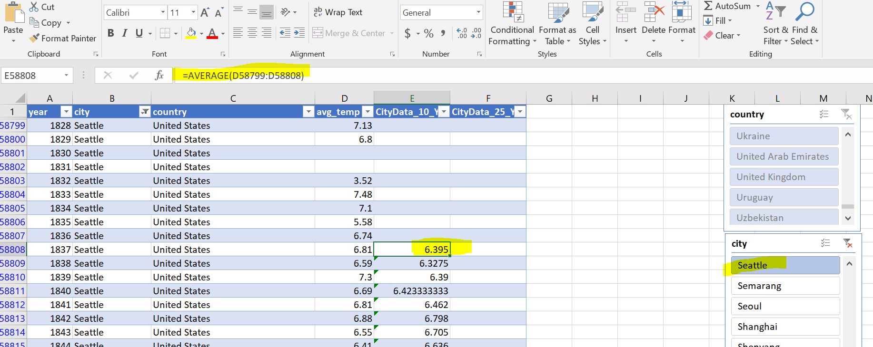

For computing Moving Average for global data, I followed the below steps:

1. Format the data in ‘global_data’ worksheet in Table format.
2. To calculate the Moving Average for over 10 years, I included a new formula ‘=AVERAGE(B2:B11)’ in a new column [GlobalData_10_Years] and for calculating Moving Average for over 25 years, I included another formula ‘=AVERAGE(B2:B26)’ in the new column [GlobalData_25_Years]. 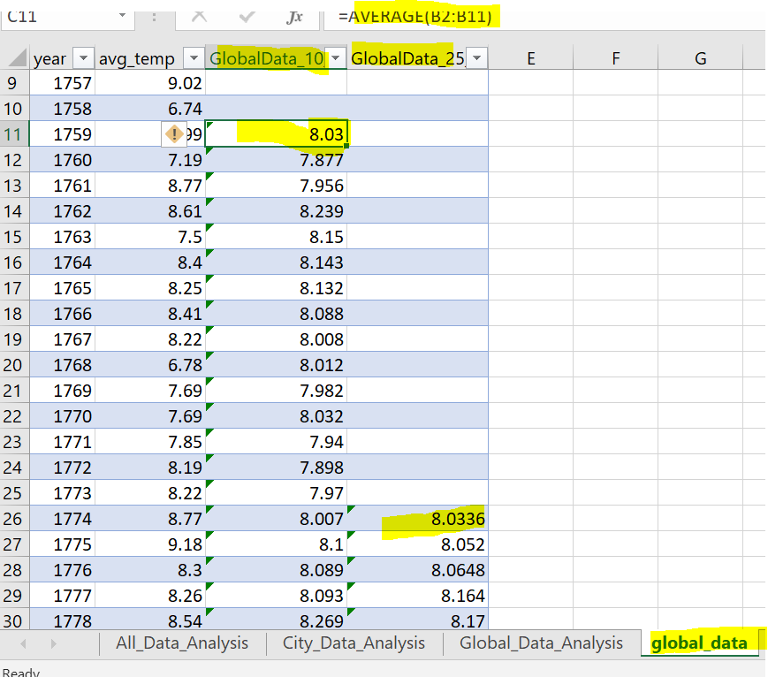

# 3.0 Chart Creation Process

To analyze the temperature trend between global and city data, I created the below chart.

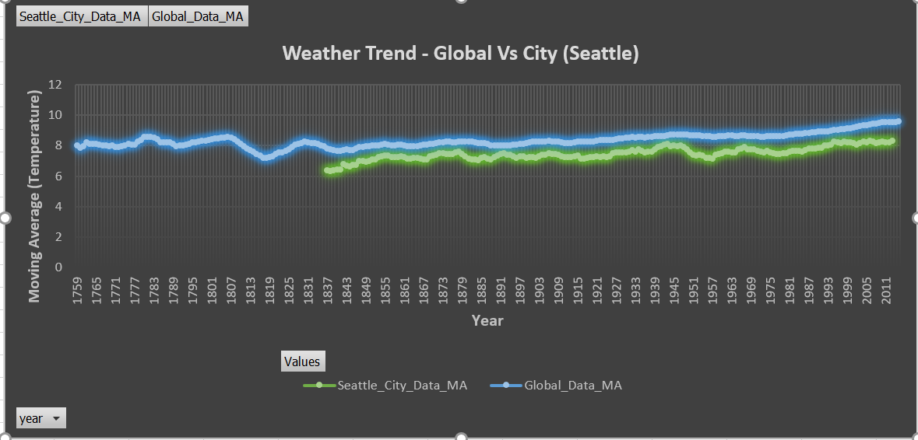

Below are the steps I followed for creating the above charts:

1. Created Data Model with ‘City data’ table and ‘Global Data’ table.
2. Created a Pivot chart, by choosing ‘Year’ as an axis and chose ‘City_Data_MA_10_Years’ and ‘Global_Data_10_Years’.

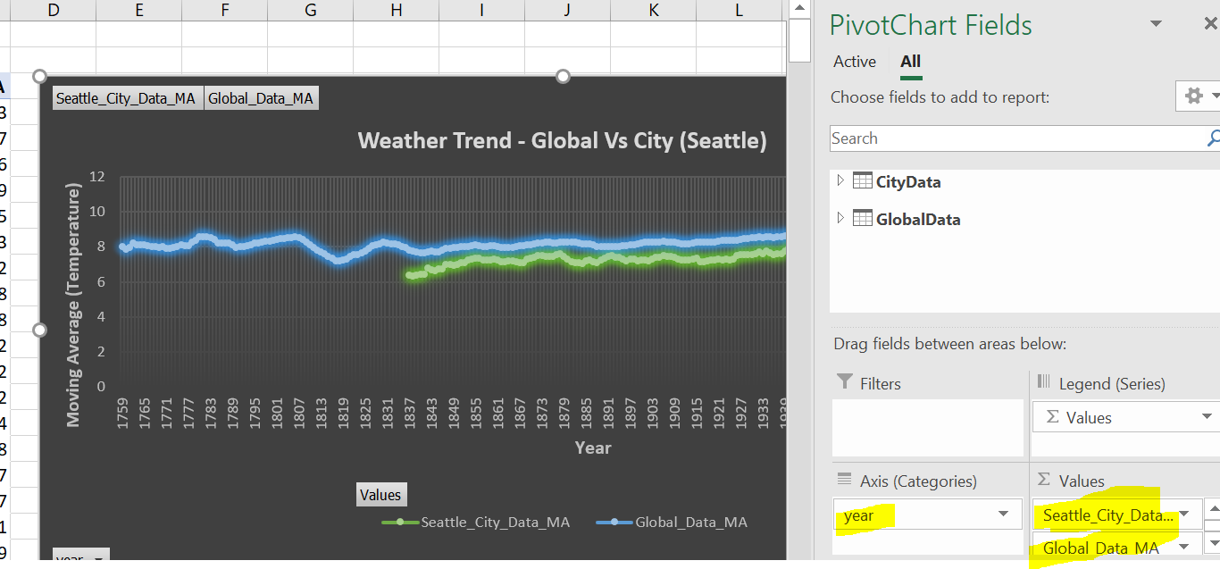

1. Added Axes titles, and chart title, as shown in the above chart.

# 4.0 Observations (Comparing Global temperature Trend Vs City temperature Trend)

**Observation #1: Seattle is cool.**

Seattle seems to be cooler, when compared to global temperature. Below is the Maximum and Minimum Moving average temperature data for both Seattle (City) and Global to prove Seattle is cooler. Seattle’s observation (Maximum and Minimum) is lower than Global data observation.

|  |  |  |
| --- | --- | --- |
|  | Seattle City | Global |
| Maximum Moving Avg. Temperature | 8.339 | 9.594 |
| Minimum Moving Avg. Temperature | 6.423 | 7.203 |

**Observation #2: Steady drop in Seattle Temperature from 1945 to 1957**

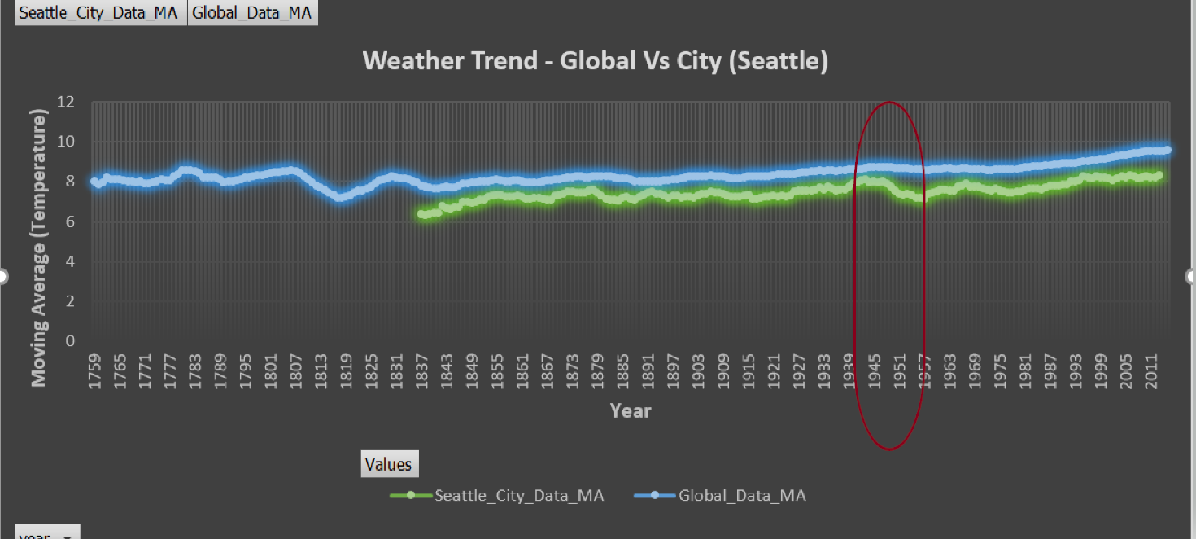

For Seattle City, from 1945 to 1957, it seems there is a sharp decline in temperature for Seattle, when compared to global temperature data. In 1947, the Moving Avg. is around 8.045 but in 1957, it dropped to 7.133. For Global, there is no sharp decline in the specified period.

|  |  |  |
| --- | --- | --- |
| Year | Seattle Moving Avg. | Global Moving Avg. |
| 1947 | 8.045 | 8.755 |
| 1948 | 7.901 | 8.744 |
| 1949 | 7.781 | 8.727 |
| 1950 | 7.577 | 8.688 |
| 1951 | 7.427 | 8.674 |
| 1952 | 7.373 | 8.665 |
| 1953 | 7.433 | 8.676 |
| 1954 | 7.353 | 8.647 |
| 1955 | 7.205 | 8.652 |
| 1956 | 7.184 | 8.612 |
| 1957 | 7.133 | 8.605 |

**Observation #3: Rate of temperature change in recent years (2002 to 2013).**

Looks like in recent years, both Seattle and Global temperature continues to raise. Though Seattle’s temperature raise is slightly lesser compared to Global, rate of change is above 3% for both Seattle and Global. **So the world is getting hotter.**

|  |  |  |
| --- | --- | --- |
|  | Seattle Moving Avg. | Global Moving Avg. |
| Year: 2002 | 8.081 | 9.249 |
| Year: 2013 | 8.336 | 9.556 |
| Rate of Change | **+3.15%** | **+3.319%** |

**Observation #4: Overall Trend.**

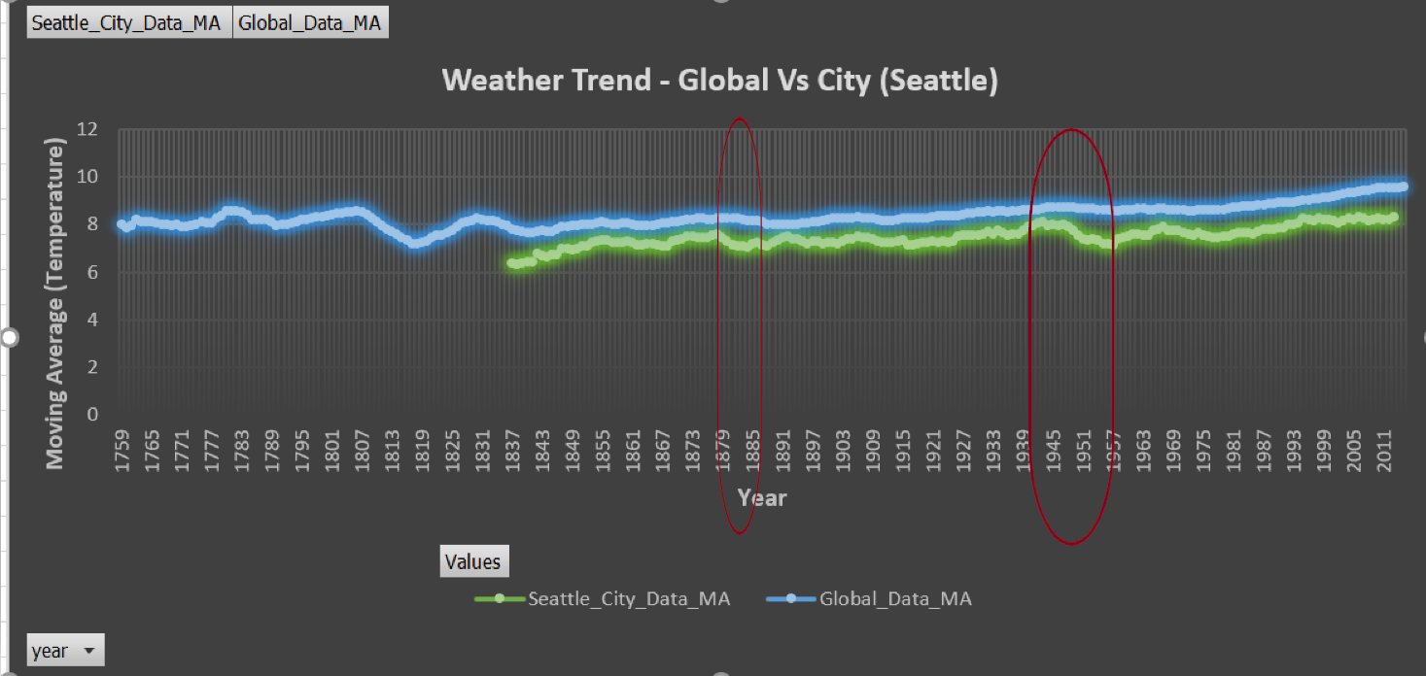

Overall Seattle (City) seems to closely follow the global trend in terms of temperature raise, even though Seattle seems to have minor dips in some periods as highlighted in the above chart. (Periods: 1878 to 1884, 1945 to 1957).